Fall 2025

Idaho Tree Farm Program

P.O. Box 581 • Rathdrum, ID 83858 • (T) 208.691.5933
www.idahotreefarm.org • admin@idahotreefarm.org

2025 Idaho Tree Farm Program

Fall Tour Review

McClintock Farms, Moyie Springs, ID
2025-2026
Officers:

• President –
Hailey Frank
Idaho Dept of Lands
hfrank@idl.idaho.gov
(T) 208-859-4309

• Vice President – McKenna Smith
Idaho Dept of Lands
msmith@idl.idaho.gov
(T) 208-245-4551

• Treasurer –
Madeline David
madelinedavid0909@gmail.com

• Administrator –
Colleen Meek
ID Tree Farm Program
admin@idahotreefarm.org
(T) 208.691.5933

2025-2026
District Chairs:
• District 1 Chair –
Phil Dipofi
Idaho Forest Group
philip.dipofi@ifg.com
(T) 208.500.8988

• District 2 Chair –
Robbie Easley
Idaho Dept of Lands
reasley@idl.idaho.gov
(T) 208.877.1121

• District 3 Chair –
John Lillehaug
All About Forestry
john@allaboutforestry.com
(T) 208.630.4076

• District 4 Chair –
Rodney Cochrane
Idaho Dept of Lands
rcochrane@idl.idaho.gov
(T) 208.682.4611

Our Fall Tour was hosted this year by Kennon and Jody McClintock at their home & family forest near Moyie Springs. We had a beautiful, sunny day for the tour as approximately 50 Tree Farmers, friends, and family gathered for an enjoyable day in the woods. As always, the day started with a social time for coffee, donuts and fellowship before heading out on the tour.

Kennon began with a brief history of their Tree Farm journey. A single 40 acre purchase in 1988 has steadily grown through various acquisitions to over 800 acres today on two separate Tree Farms just east of Moyie Springs.

The parcels are well accessed, and we were able to use a school bus to ferry the group around in a single vehicle for the tour. As a professional forester himself, Kennon crafted the management plans and activity schedule personally for the parcels. The dedication and care of the entire family was evident throughout the day. At the various stops we viewed examples of precommercial thinning, plantations, a cedar seed orchard, and harvests varying from smaller individual tree salvage cuts to larger commercial harvest. Along with the various forest activities, Kennon and Jody have also managed some of the acreage for things such as ag land, fruit trees, and homesite. The family does all the work themselves that time allows, though contract crews are also hired occasionally to help with some of the larger projects.

Toward the end of the tour, we were able to get a look at the machinery used in their activities and talk a bit about some of the challenges and lessons learned along the way. Kennon has been very diligent in searching out markets for as much of the material harvested as possible in order to make the most out of his various stand entries, maximizing both economic and silvicultural returns. Also, he and Jody have been fine ambassadors to the public, opening their Tree Farm to numerous forest tours and field events for many years.

The day wrapped up at the Moyie Community Center for a box lunch and one last round of fellowship & conversation before parting for the day. Everyone seemed to have a great time. A huge “Thank You” to the McClintock Family for hosting!

Memories from the Fall Tour
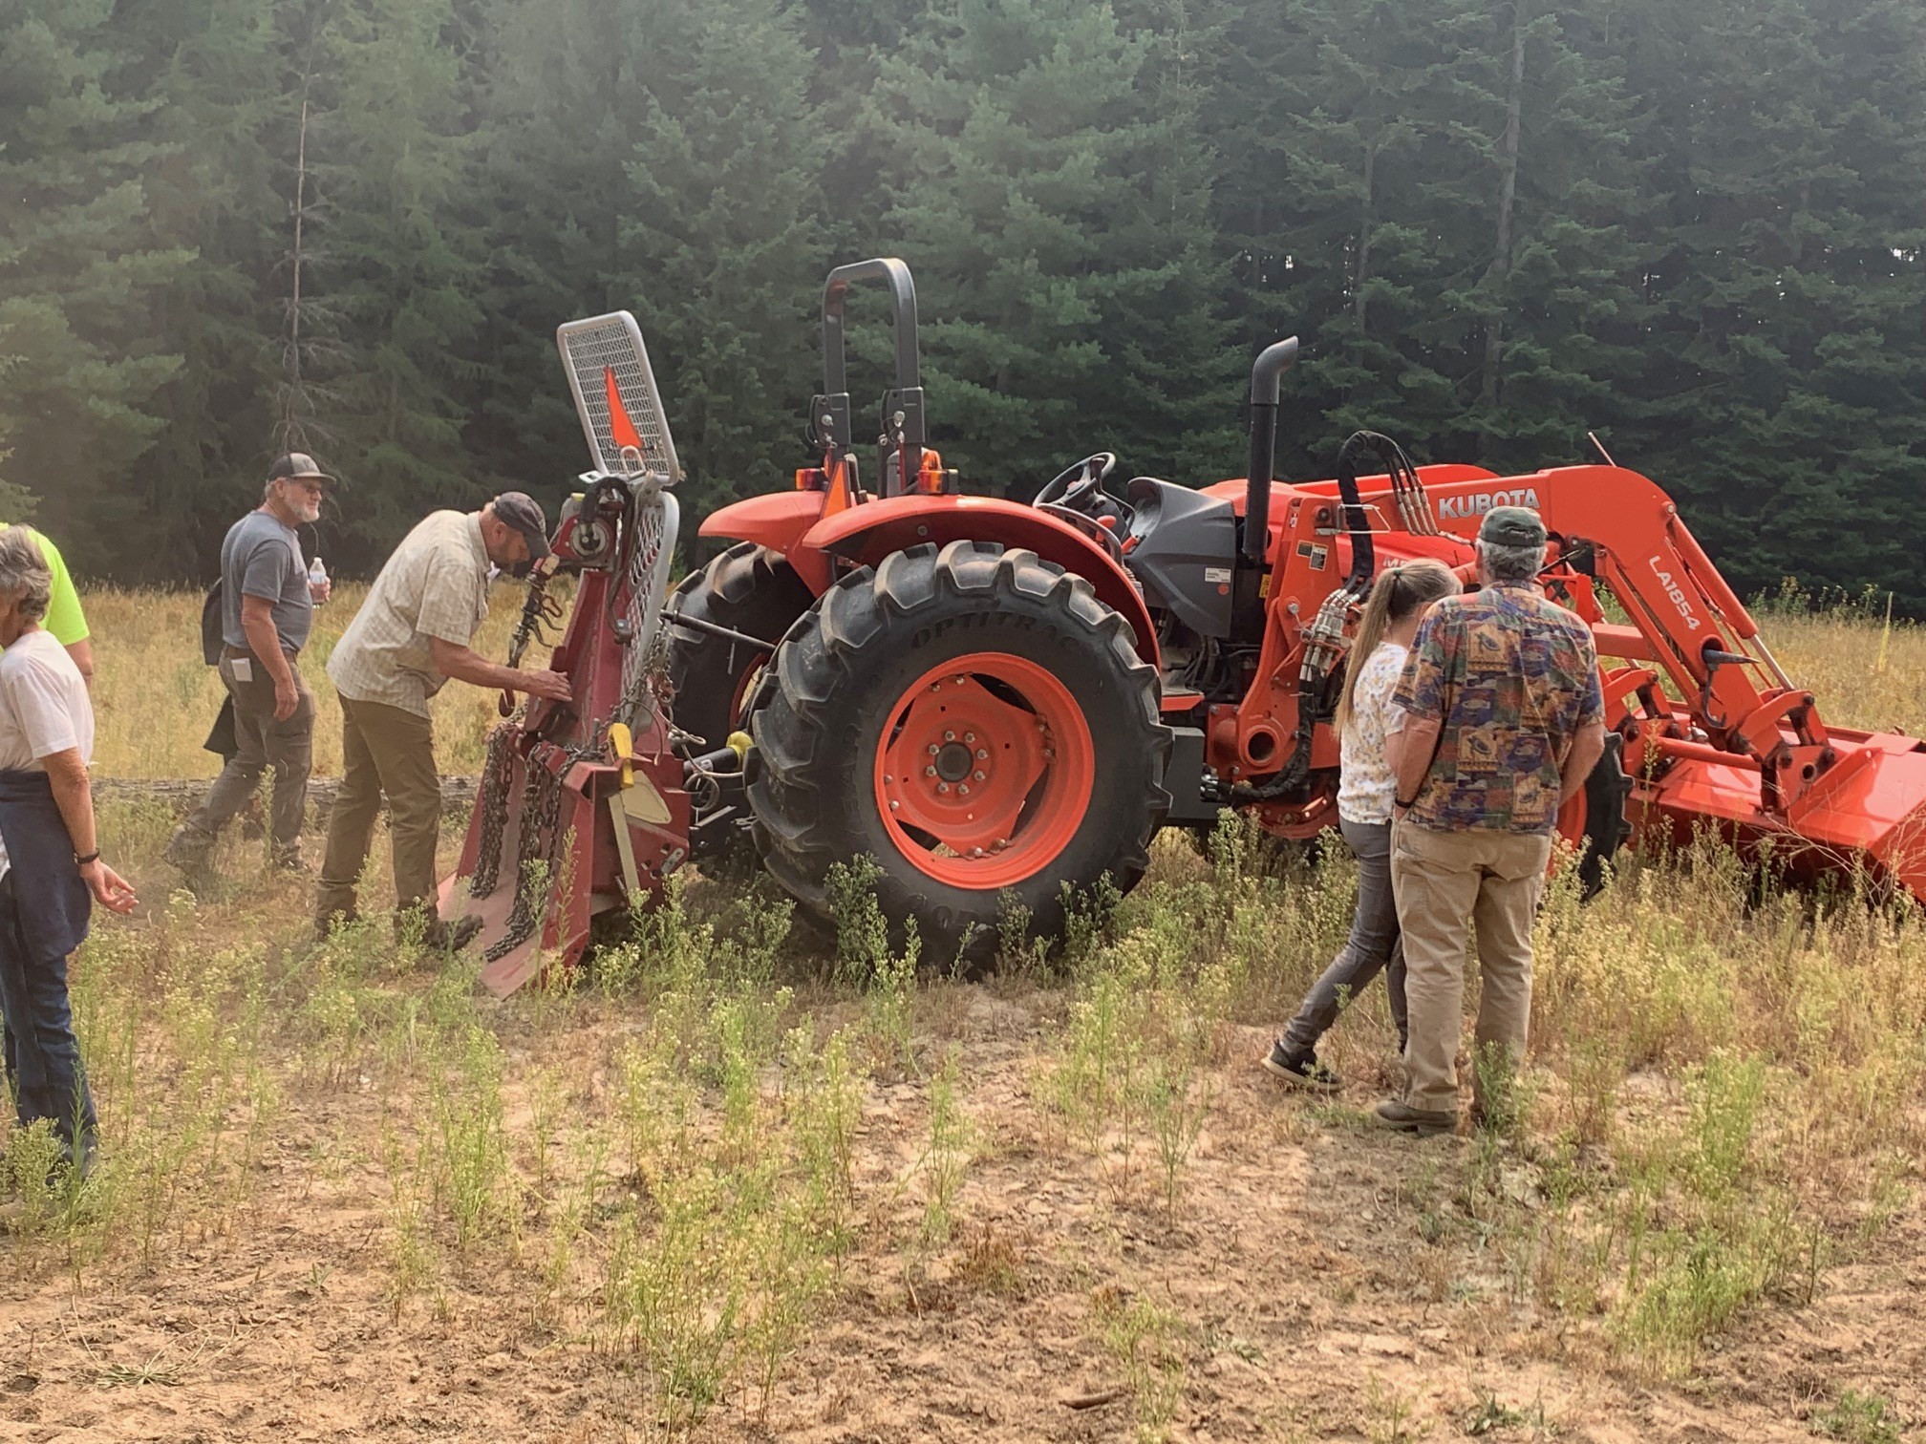
Tools of the Trade…
Precommercial Thinning Area
Cedar seed orchard
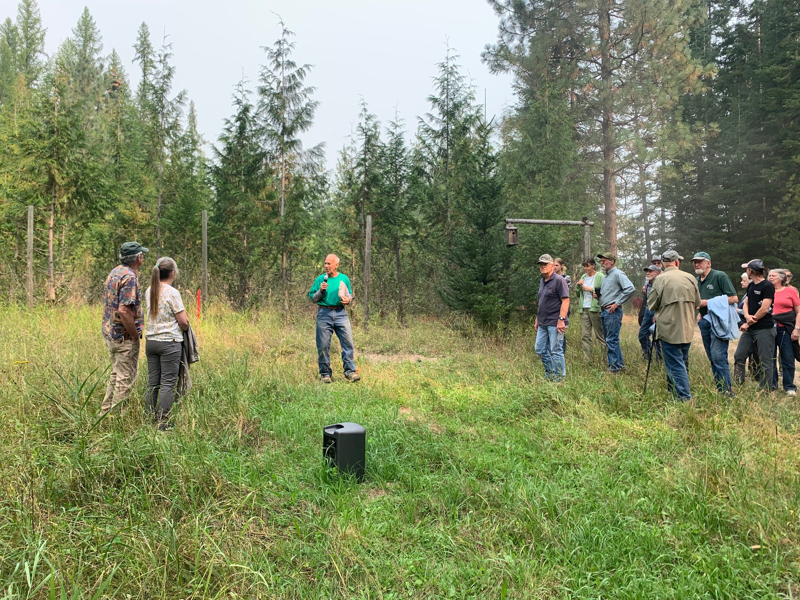
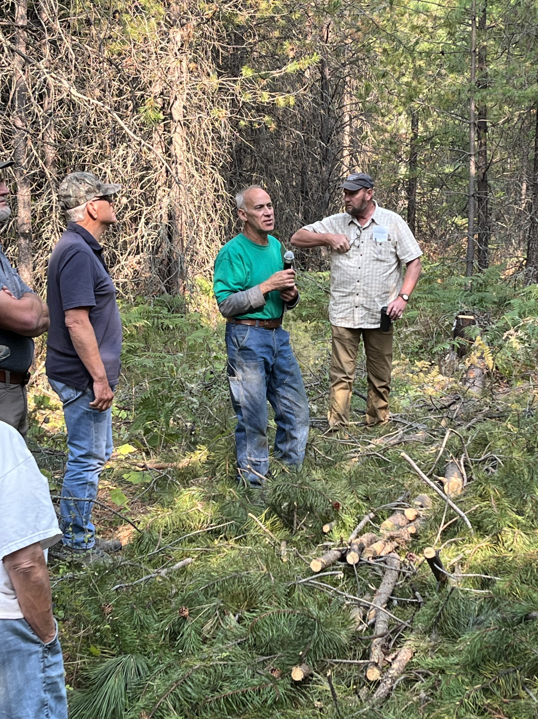
Larch Plantation
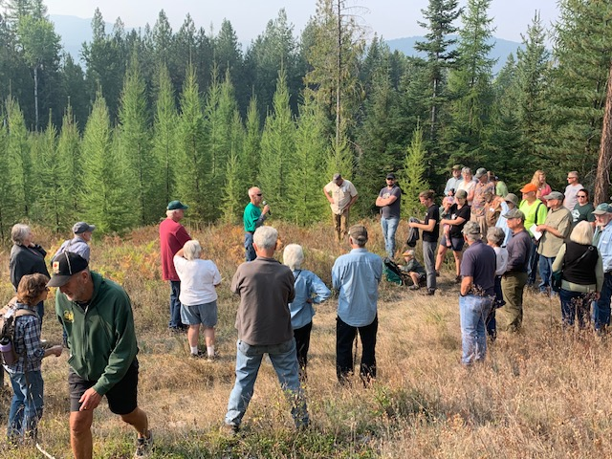
Getting ready to Load Up
Everybody loves a doughnut
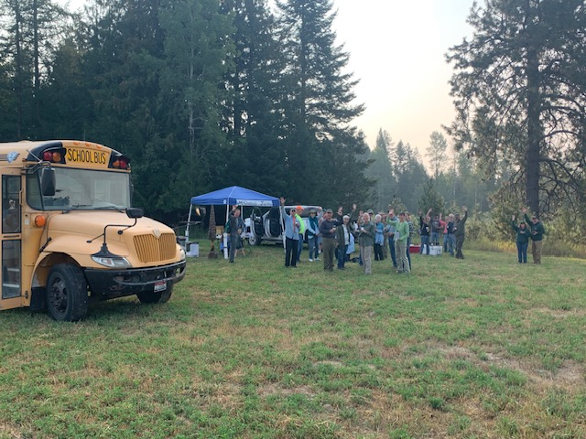
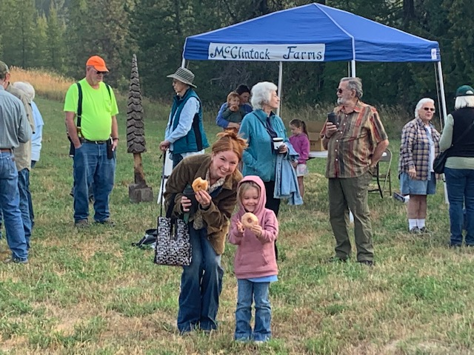


Pheromone Treatment Options for DF Beetle and Mountain Pine Beetle
Hannah Hallowell and Erika Eidson, ID Dept of Lands Entomology

As winter approaches, this time of year is a great opportunity to plan any management strategies for bark beetle problems, particularly pheromone treatments. In areas where Douglas-fir beetle or mountain pine beetle are a concern, using pheromones may be a cost-effective way to protect trees in the short-term.
Many insects use pheromones, which are essentially “scents” that help them communicate with others of the same species. Pheromones may be attractive, causing bark beetles to aggregate and attack a tree all at once, or they may be repellent (anti-aggregation), acting like a “No Vacancy” sign telling bark beetles that a tree is already full. Researchers have successfully replicated the repellent pheromone for Douglas-fir beetle (MCH) and mountain pine beetle (Verbenone). These pheromones can be purchased in small bubbles or packs that are stapled to healthy trees and slowly diffuse the pheromones. When timed properly, the pheromones trick bark beetles which are searching for host trees into thinking that there is no longer enough food in the treated trees or stands. It signals the beetles to pass by, which can help prevent new bark beetle attacks.

So, when are pheromone treatments effective? It is critical to remember that pheromones are species-specific; there is no universally repellent pheromone that will protect trees from all types of pests. MCH will only repel Douglas-fir beetles, and Verbenone will only repel mountain pine beetles. There are no other repellent bark beetle pheromones currently on the market. It’s also important to remember that pheromones are only effective at protecting uninfested trees, they can’t save trees that are already infested. Knowing a little bit about Douglas-fir beetle and mountain pine beetle can help identify trees and stands that may be at risk and could be good candidates for pheromones.

Douglas-fir beetles attack Douglas-fir trees, preferring large (where average diameter is >14 inches), densely growing, and older trees. They can especially be an issue in areas affected by root diseases, which are common in north Idaho. Situations where wind, storm damage, or forest management practices have left fresh Douglas-fir logs on the ground are a major risk factor for starting an outbreak. Beetles will colonize the fresh downed logs and their offspring can move into standing trees the following year. Outbreaks typically last three years, and without intervention, can kill a large number of mature Douglas-fir trees.

Mountain pine beetles can attack any of our native pine species that are >8” diameter, but they tend to target densely growing lodgepole, stressed ponderosa, and large-diameter western white pines. Mountain pine beetle outbreaks, often triggered by drought or other issues, can be large-scale and continue for many years until conditions change or beetles run out of suitable host trees. It’s also important to note that mountain pine beetle and western pine beetle can be outwardly difficult to distinguish in ponderosa pine, but correct identification is critical since Verbenone is not effective against western pine beetle.

In general, thinning stands that are too dense will be the best long-term strategy to increase resistance to bark beetle attacks, but when there is an immediate need for tree protection, pheromones serve as a good temporary alternative. Pheromones can be applied to protect single trees or in a grid pattern to protect larger areas, or a combination of single-tree and grid treatments. They are only effective for one season, so when bark beetle concerns are ongoing, pheromones would need to be re-applied in future years until conditions change.

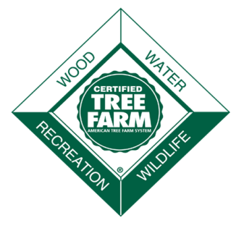
(Continued on Page 4)
Pheromone Treatment Options (Continued from Page 3)

Let’s take a look at some examples of common situations where pheromone treatments may be a good choice:
- I have specific trees I want to protect, such as high-value pines or Douglas-fir trees near my home or campsite, or seed trees or leave trees left after a harvest that I want to maintain for regeneration or other purposes

- There is an active infestation of Douglas-fir beetle or mountain pine beetle on my property or in the vicinity and I want to protect my healthy trees until it dies down

- I have large green Douglas-fir logs on the ground this winter that can’t be cleaned up before spring

- I have a Douglas-fir forest with root disease, and I want to keep the stressed trees as long as possible, even if that involves treating them with pheromones every year

- I am planning a harvest soon and want to protect my trees until they can be logged

While there are plenty of situations where pheromones can be a helpful tool, not all situations may warrant pheromones, so consult with a forest entomologist. For pheromones to be effective, they need to be applied before beetles emerge to find new trees in the spring. The timetable below gives a general idea of when to plan treatments, order pheromone, and place pheromone bubble caps or packs in a typical year.

Pheromone type | Scout trees and plan treatments | Order pheromone | Apply pheromone
MCH | September-December | Before March | Early to mid-April
Verbenone | September-February | Before May | Early to mid-June

Both MCH and Verbenone have different application spacing depending on the formulation and situation, so reach out to the Idaho Department of Lands Forest Health Program for details on planning, ordering, and applying these pheromone treatments.

For additional information on Douglas-fir beetle, read the IDL Douglas-fir beetle fact sheet or the USFS Douglas-fir beetle management guide. Details on MCH application strategies can also be found in the MCH Handbook.

For additional information on mountain pine beetle, read the IDL mountain pine beetle fact sheet or the USFS mountain pine beetle management guide.

To contact the Idaho Department of Lands Forest Health Program, call (208)769-1525 or email ForestHealth@IDL.Idaho.gov.

Current Topics in Forest Health is an Idaho Forest Stewardship program, co-sponsored by University of Idaho Extension, the Idaho Department of Lands, and many other agencies and organizations. For questions on the program, contact the University of Idaho Extension office in Kootenai County at (208) 292-2525.
Animals, plants, insects, and diseases can sometimes impede reforestation, wildlife habitat, or other forest stewardship goals. Current Topics in Forest Health is an annual program that updates forest owners, foresters, and others on methods to improve forest health.
Current Topics in Forest Health will be held in Coeur d’Alene, from 8:30 a.m. to 4:15 p.m. on Friday, December 12, 2025 in Room 106 of the Meyer Health and Science Building at the North Idaho College. The program is eligible for Idaho pesticide license re-certification credits (6 credits), Society of American Foresters continuing forestry education credits (5.5 hours, Cat. 1), and Idaho Pro-Logger continuing education credits (5 credits). The program can accommodate up to 95 people. Participants should pre-register by Friday, December 5, 2025 to ensure their place. Registration is available online with a credit card by going to https://marketplace.uidaho.edu/, scrolling to, then clicking on “University of Idaho Extension: Panhandle Forestry”. A $26 registration fee covers handouts and refreshments. Registration forms are also available at local University of Idaho Extension Offices.
Current Topics in Forest Health, U of I Forestry Extension

From forestcongress.org website: “The American Forest Congress is a proud tradition that has influenced the direction of forest conservation and management in America for more than a century. Since the first American Forest Congress in 1882 to the most recent in 2022, these seminal events have led directly to major outcomes in the forestry sector, including the creation of the U.S. Forest Service, the establishment of the eastern National Forests, new community-based and collaborative approaches to forestry, and efforts to advance the leadership of women within the forest community.”
The 9th American Forest Congress was held this past July in Washington, D.C. and our program was represented by President Hailey Frank-Bennett. The attendees, grouped into subcommittees, worked on various forest related Resolutions. If passed by the larger group, they would be sent along to our policy makers for consideration in future forestry measures. Hailey and her group worked on a statement expressing the importance of reforestation and necessary nursery capacity.
For a detailed look at the various Resolutions, Steering Committee, and more information on the Congress, click on the following links: Resolutions – 9th American Forest Congress
About – 9th American Forest Congress

9th American Forest Congress

Welcome New Members!

Events to Highlight
Jan 20, 2026 Idaho Tree Farm Committee Meeting, CDA, ID
March 29-31, 2026 Family Forest Landowners & Managers Conference, Moscow, ID
March 30, 2026, Idaho Tree Farm Program Annual Meeting, Moscow, ID

The Idaho Tree Farm Committee extends a special welcome to the 2 newest Idaho Tree Farm Program’s certified members. Thank you to the District Chairs and Inspecting Foresters for promoting membership in the Idaho Tree Farm Program through the American Tree Farm System®.
As a current member, and a steward of the land, we appreciate your current support of the program and your management of the forestland for pride and pleasure. Thank you for your continued commitment to protecting watersheds and wildlife habitat, conserving soil and, at the same time, producing the wood America needs and uses.

Tree Farm Member |  | Acreage | County | Inspecting Forester
Wayne Lynn |  | 104 | Latah | Robbie Easley
Aaron & Kimberley Fister |  | 34 | Bonner | Andy Eckberg

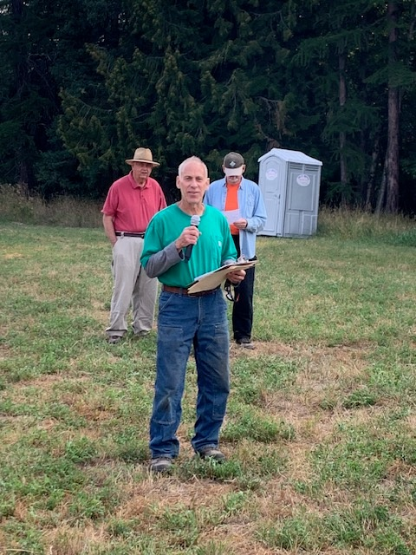

Stay Informed…..
In case you are ever wondering what is going on at the committee level, our Minutes are now being posted on the Idaho Tree Farm Program website. Just log onto our website for Minutes of previous sessions, contact information, upcoming events, and other news of note to help you in your Tree Farm endeavors.

We’re on the Web!
Learn more at:
www.idahotreefarm.org

The purpose of the Idaho Tree Farm Program is to promote better forest management among family forest owners. The vehicle for achieving this aim is the American Tree Farm System® (ATFS), sponsored nationally by the American Forest Foundation (AFF), statewide by the Idaho SFI State Implementation Committee (SFI SIC), and administered by the Idaho Tree Farm Committee (State Committee).

About Our Organization…

Q – What’s This?

A – A Tree Farmer “out standing” in his field

(hope they aren’t all waiting for the outhouse…)

Congratulations once again to Kennon, Jody and all the McClintock family. You are all most certainly Outstanding in your field!

