**Spring/Summer 2019**

Idaho Tree Farm Program

P.O. Box 2659 • Coeur d’Alene, ID 83814 • (T) 208.667.4641, ext 503   
www.idahotreefarm.org • admin@idahotreefarm.org

Introducing our 2019 Idaho

*Outstanding Award Winners !!*

***2019-2020  
Officers:***

• President –

Sean Hammond  
Hammond Logging, LLC  
(T) 208.610.8754

• Vice President –

• Treasurer –   
Madeline David  
madelinedavid@hughes.net

• Administrator –   
Colleen Meek  
ID Tree Farm Program

admin@idahotreefarm.org

(T) 208.667.4641 Ex 503

***2019-2020  
District Chairs:***

• District 1 Chair –  
Andy Eckberg  
Idaho Forest Group  
aeckberg@idfg.com

(T) 208.255.3276

• District 2 Chair –  
Tim Schaffer  
Bennett Lumber Products  
(T) 208.819.1214

• District 3 Chair –  
John Lillehaug  
All About Forestry  
(T) 208.630.4076

The 2019 Family Forest Landowners & Managers Conference held this past March in Moscow was another rousing success. Attendance was a whopping 300 folks from all around our area! Many good comments were received on the speakers and program.

A high point each year is the annual meeting of our Idaho Tree Farm Program. Over 70 people were in attendance as President Sean Hammond went through a review of our activities over the season and gave a peek at what is upcoming for this year. He and Past President Russ Hegedus recognized the efforts of our Inspectors for their hard work and spoke a bit about the upcoming 3rd party audit review of the program (which should be completed by the time you receive this newsletter). The meeting concluded with the announcement of our Outstanding Idaho Tree Farmer, Inspector, and Logger of the year.

Outstanding Tree Farmer of the Year went to Larry and Margie Cooke of St Maries and their Forever Green Tree Farm. The Tree Farm consists of an 80 acre tract of managed forest and another 20 acres of Christmas tree and nursery stock. The farm was started in 1983 and has been intensively managed by them since. They have undertaken three significant harvests in the last 34 years as well as several silvicultural and stand improvement practices applied over the years.

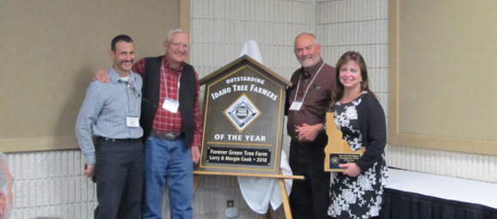

Larry and Margie along with President Sean and our sign maker Steve Funk

Larry says “*We raise several species of pines, firs, and spruce for the landscape market. We are primarily a wholesale producer but will market directly to the final end-user based on a quantity purchase. We are a full service grower and marketing company*.”

Recap - Idaho Tree Farm Annual Meeting

## (Continued from page one)

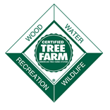

Congratulations to all of our Idaho award winners, Great Job!!

Thomas Mackey, Outstanding Idaho Logger of the Year

Our final award of the night went to Thomas Mackey for Outstanding Idaho Logger of the Year. Thomas operates Northwest Tree & Reclamation, based in Bonners Ferry. He was nominated by Past Chair Russ Hegedus in recognition of his fine work on the ground, attention to detail and dedication to getting the job “just right” for each landowner. All the good intentions in the management plan are of no use without someone to properly bring them to fruition and we appreciate contractors like Thomas very much.

Robert Barkley introducing Robbie Easley, Outstanding Idaho Inspector

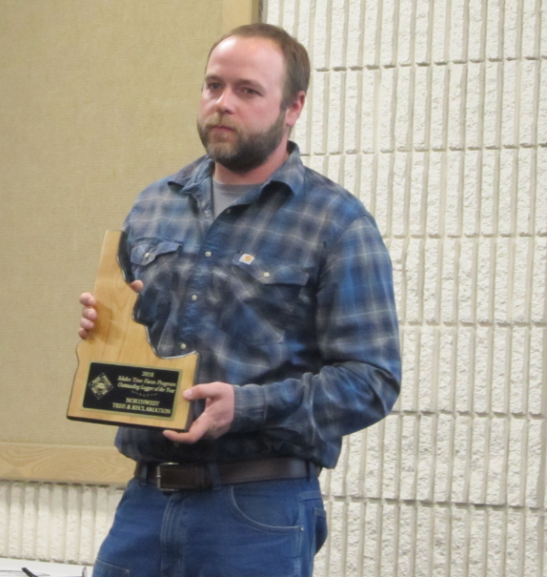

Our Outstanding Idaho Inspector of the year award went to Robbie Easley. Robbie is a Lands Resource Specialist for the IDL in the Ponderosa Area and a University of Idaho Forestry graduate. Robert Barkley, Private Forestry Specialist out of Deary, said “*I nominated Robbie because he showed a true interest in the Tree Farm goals. Both as a Tree Farmer and a Tree Farm Inspector his commitment is strong to make Tree Farm a successful program in Idaho*.” Robbie is certainly no stranger to ATFS as his family has had a Tree Farm near Priest River for many years. His award included a plaque and embroidered cruiser vest.

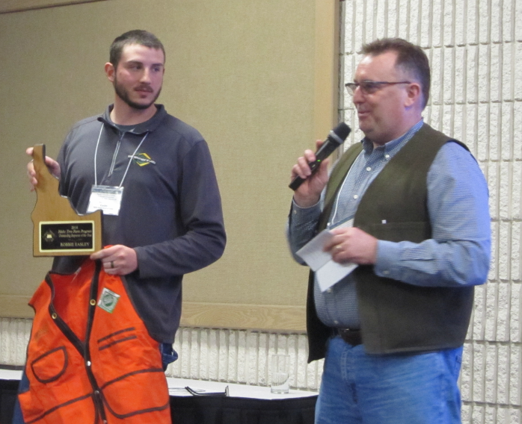

Regarding their stewardship, our District 2 Chair Tim Shaffer said, “*The Cooke’s diligent care for the land and their passion for sound silviculture is evident as you walk through their forest. Their Tree Farm is an excellent example of the type of family centered operation that represents many of our Idaho Tree Farms*.”

Tree Farming has been a family venture for them and today 13 grandchildren are also involved. Their story continues and we invite you out to take a look for yourself at our Fall Field Tour this coming September.

Welcome Angela Wells – Western Tree Farm Manager

**Sara Anrrich**, ATFS Senior Manager Woodlands Programs – “Throughout the [2018 program assessment](https://protect-us.mimecast.com/s/ZXG2Co2XqAcmxpBTgpnwA) and [National Leadership Conference](https://protect-us.mimecast.com/s/7-E2CpYL09FZXEvtjbHxK), *ATFS leaders and volunteers made it clear that increasing the capacity of state programs and improving communications are two key ways we can work* **together** *to strengthen, grow and increase the impact of the ATFS program. One of the most important investments we have made thus far is bringing on additional staff capacity to support state programs. This month, we invite you to get to know* ***Angela Wells, Western Tree Farm Manager.”***

Explaining her duties as Western Tree Farm Manager Angela says – “*In this position, I will work with nine state programs around the West to determine the best way to grow, strengthen, or increase the impact of their network. For some, this might mean streamlining enrollment of new landowners by making it easier to develop management plans. For others, it might be spreading the workload of inspections more equitably or recruiting a more capacity to Tree Farm Steering Committees. Others may be in a position that they simply want to provide more services to their existing membership and capture the positive results generated on the ground. I am here to support state programs, not to tell them what to do, but to work with them to determine what makes Tree Farm important in their state and provide resources to reach more people with the good news of sustainable family forest management for wood, wildlife, water, and recreation*.”

Angela has a long association with ATFS, beginning with her own family’s Tree Farm in the Entiat Valley of north central Washington (soon to be a 50 year member in 2023). As previously printed in the Washington Tree Farm newsletter she recalls at 16 inheriting her father’s 1983 red Volkswagen rabbit pickup to commute between school and their Tree Farm – “*Other than being the most un-cool vehicle in the high school parking lot, its other distinguishing feature was the green and white “wood, wildlife, water, and recreation” sticker in the back window. It became standard practice for me to explain to inquiring friends and strangers that our membership in the Tree Farm program meant that we managed our forest to be healthy, a haven for animals, resilient to wildfire, and a retreat from the busy world.”*

Since that time she earned a bachelor’s degree in forestry at the University of Washington and a master’s degree from Oregon State. Positions with the USFS followed, including a stint as a hotshot fire crew member. Most recently she has been with the Montana Department of Natural Resources and Conservation managing stewardship programs for family forest owners and serving in the leadership of the Montana Tree Farm Program.

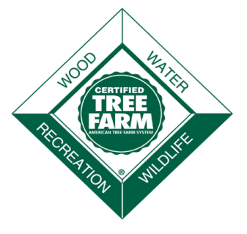

Welcome aboard Angela!



Marcus has attended a couple of these events now as both a Tree Farmer and IFOA member. He has written a recap of his latest trip back east which, like the old Frank Capra movie, he has titled “Mr Smith Goes to Washington”.

Here are a few highlights:

Every other year, the American Forest Foundation (AFF) hosts an event called the AFF Washington, DC Fly-In in which they invite Tree Farmers and forestry professionals from around the nation to fly to Washington, D.C. in order to meet with their elected representatives. With more than 50 participants from 20 states, attendees had meetings that touched on many important issues that private forest landowners are facing. These concerns included the importance of having more resources to support disaster relief, the need to increase available markets for family forest owners and even ensuring the best implementation of the 2018 Farm Bill programs that help family forest landowners. Federal policies that keep forests as forests encourage conservation activities, and efforts to strengthen markets for forest products were the focus on this 2 day event.

While in DC Marcus, along with several other Tree Farmers and American Forest Foundation (AFF) staff, met with several decision makers, relating to them issues of importance to us back home. Appointments included USFS Chief Vicki Christiansen, as well as visits with staff from our Idaho delegation of Congressman Mike Simpson, Congressman Russ Fulcher, Senator Jim Risch, and Senator Mike Crapo. Marcus has written a detailed account of each meeting and items discussed. If you wish to read the full transcript, click on the link [**https://ssl.gstatic.com/docs/doclist/images/icon_10_generic_list.png 2019 AFF Washington DC Fly-in Summary Report Fi...**](https://protect-us.mimecast.com/s/P-U3C0RD6Ahz60NSDI_6P)

WA DC Fly-In Report,

Marcus Smith, Idaho Tree Farmer

This is always a fun and informative event for your entire family, and something that will help you with almost any activity planned for your Tree Farm. Come join with other family forest owners from both Idaho and Washington for classes and activities on topics such as forest health, native plants, fire protection, riparian areas, and wetland protection. For all you budding do-it-yourselfers, the ever popular Forest Dan will demonstrate safe tree felling techniques and chainsaw maintenance.

Is the latest information on defoliators, noxious weeds, root rot, and log scaling are on your wish list?

Are you interested in the new trespass and forest fire protection laws?

Do you want to have the chance to network with other private landowners throughout our area?

Then, this is an event just for you!

Individual registration is $20 and registration for the whole family is $30.

For more information, driving instructions, registration, map and schedule, log onto the Idaho Forest Owners Assn website at: <http://www.idahoforestowners.org/>

WA-ID Field Day – Saturday June 22, 2019

Near Deary, ID

**“Forest Insect & Disease Field Day” to be held July 26 in Coeur d’Alene**

On Friday, July 26th, the “Forest Insect & Disease Field Day” will give participants firsthand exposure to a wide range of organisms that impair the growth of trees and forests in northern Idaho, including: various bark beetle species; *Armillaria* and other root diseases; white pine blister rust; indian paint fungus, pini rot and other stem decays; and dwarf mistletoes. Experts will help participants identify insect and disease symptoms and discuss practical long and short term methods of dealing with them.

# **Forest Measurements Class to be held in Sandpoint, July 13**

A University of Idaho Extension program titled “Measuring Your Trees” is designed to give forest owners a basic understanding of forest measurements. It also will help them collect some of their own data and strengthen their interactions with professional foresters and technicians regarding data-based forest management decisions

**White Pine Restoration Workshop planned near Priest Lake, June 21, 2019**

Blister rust is a non-native disease that devastated western white pine trees in the Inland Northwest. Pruning the lower branches of young white pine can increase their survival by half. A workshop titled “Pruning to Restore White Pine”, to be held Friday, June 21, at the Inn at Priest Lake (located at 5310 Dickensheet Road in Coolin, ID) will help foresters, family forest owners, and forestry contractors learn how to combat white pine blister rust through pruning.

**Forest Thinning & Pruning Field Day   
to be held in Sandpoint, June 22nd**

Trees killed by bark beetle attacks always make forest owners ask: “what can we do about it?” Whether you have problems with insects or disease, fire, or just want to help forest growth, the response from foresters is nearly universal: ***thin your forest***. This is especially true in northern Idaho, where forests frequently become overstocked. Thinning and pruning can favor better adapted tree species, improve tree quality, invigorate tree growth, reduce fire risk, improve access, and enhance many other values. In June, local forest owners can learn how to implement these practices more effectively in a “Thinning & Pruning Field Day”.

**For more information or to register, contact**

**Chris Schnepf – Area Extension Educator, CdA – (208)-446-1680** [**cschnepf@uidaho.edu**](mailto:cschnepf@uidaho.edu)

**Bill Warren, Extension Educator, Orofino – (208)-476-4434** [**williamw@uidaho.edu**](mailto:williamw@uidaho.edu)

**Randy Brooks, Extension Forestry Specialist, Moscow – (208)–885-6356** [**rbrooks@uidaho.edu**](mailto:rbrooks@uidaho.edu)

**Or log onto www.uidaho.edu/extension/forestry**

Upcoming University of Idaho Extension Forestry Classes

Here is a sample of classes being offered by U of I Extension Forestry this year.



Forest Health Updates, Idaho Department of Lands

Tom Eckberg. Forest Health Program Manager Idaho Dept of Lands

**Winter and insects**

After winter weather turns into spring, and the trees wake up, we often get questions like “Was it cold enough last winter to kill of the forest insects that can kill my trees?” February in northern Idaho seemed cold, but it almost never gets cold enough in northern Idaho to kill bark beetles. Sustained temperatures well below zero (-40OFfor a week) are required to kill bark beetles above the snow line. Temperatures that fall below zero in the fall or spring when the beetle larvae are preparing for or “waking up” from winter can be lethal, but this past winter probably falls into the “normal” category. Most forest insects have evolved in this area and are acclimated to the temperatures that normally occur here. Defoliating insects such as the western spruce budworm and Douglas-fir tussock moth, which feed on newly developing foliage ARE susceptible to late spring frosts. Such events have occurred in Idaho and have impacted populations. The frost kills the new Douglas-fir or grand fir growth that the larvae first feed on. There is currently a Douglas-fir tussock moth outbreak occurring in southern Idaho in and adjacent to the Boise National Forest (Valley and Boise Counties). Last winter had no effect on the overwintering egg masses, but the outbreak is likely to collapse this year due to natural enemies.

**Winter damage and bark beetles**

The heavy snows in February may have caused broken tops or uprooted trees throughout Idaho. Broken tops and down pines (both ponderosa and lodgepole), Douglas-fir or Engelmann spruce are suitable habitat for certain bark beetles. Pine engraver (*Ips pini*) is highly attracted to damaged pines and has already flown in the Coeur d’Alene area as of mid-May. This bark beetle overwinters in the adult stage and starts to fly as the weather warms, laying eggs in slash piles, uprooted trees and broken tops. Once eggs are laid, another generation of beetles emerges from the slash in approximately six weeks (mid to late June) to attack standing trees. Landowners can treat the slash by chipping, cutting it into smaller pieces (such as turning it into firewood), or hauling it to county disposal sites if they are available. The idea is to have it dry out, so putting it in a sunny location will speed the drying. If the wood is kept on site, DO NOT stack green infested wood next to healthy trees. Green Douglas-fir that was winter damaged or knocked down due to wind is likely to be attacked by the Douglas-fir beetle (*Dendroctonus pseudotsugae*). This species also overwinters as an adult, and has already flown in the Coeur d’Alene and McCall areas. Unlike pine engraver, this species only has one generation per year, and will emerge from logs next May. If enough trees were damaged to make a truckload, by all mean take them to the mill. If only a few were damaged and you burn firewood, processing them into 16”-18” pieces and splitting them will dry them out enough that the larvae will not likely survive a full year. Engelmann spruce logs or damaged trees can be infested by the spruce beetle (*Dendroctonus rufipennis*). Though not as common or problematic as pine engraver or Douglas-fir beetle, it can cause problems at higher elevations or where spruce is more common (such as the McCall area). This species requires one or two years to develop, so the measures outlined above will work for this one as well.

(Forest Health Updates Continued on Next Page)



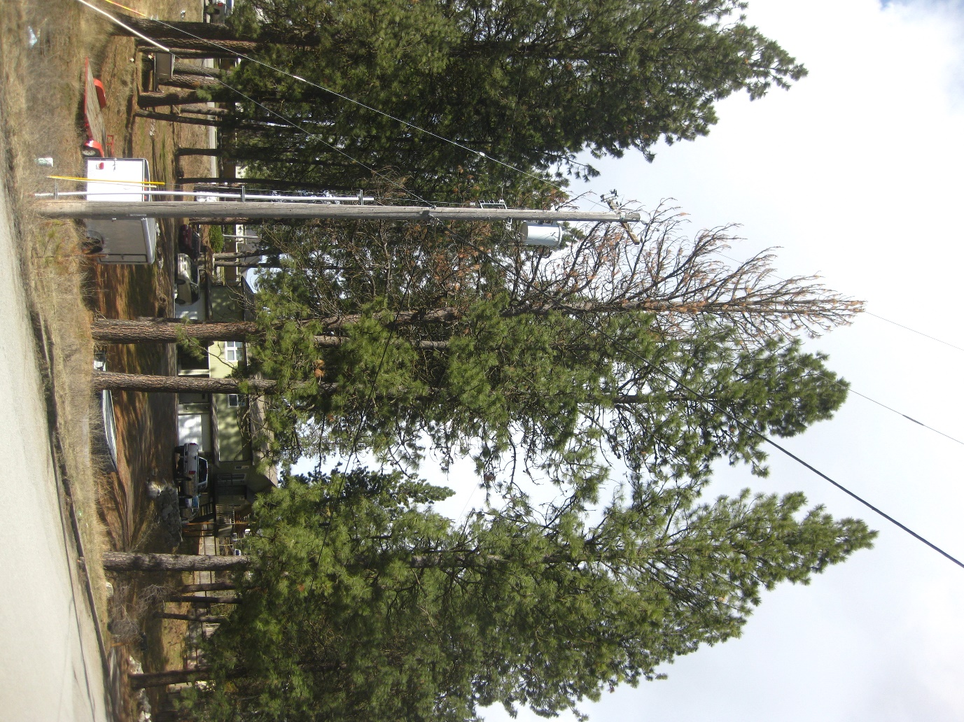

Figure 1

The same trees in March 2018.

Figure 2

Storm damaged ponderosa pine that was decked and firewood stacked next to standing green trees in November 2015.. These trees were dead by 2017.

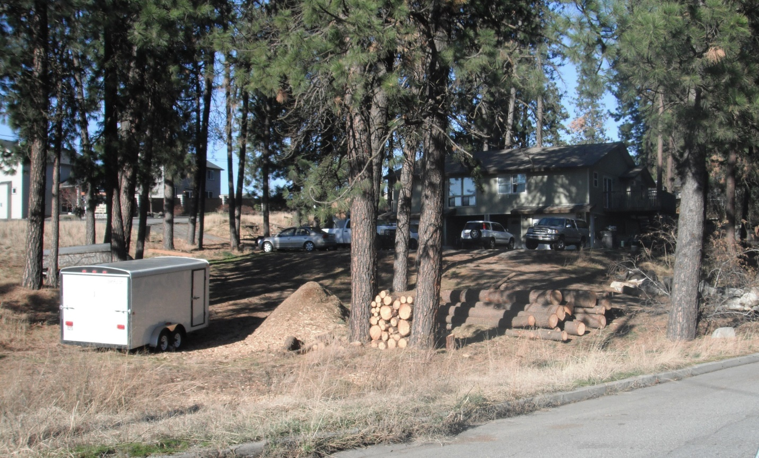

Forest Health Updates, Idaho Department of Lands

(continued from page 6)



*Events to Highlight*

**June 22, 2019** – WA/ID Forest Landowners Field Day, Deary, ID

**July 18, 2019 –** Idaho Tree Farm Program quarterly meeting – CDA, ID

**September, 2019** – ITFP Fall Field Tour, Forever Green Tree Farm, St Maries, ID (specific date TBA)

**October 17, 2019** - Idaho Tree Farm Program quarterly meeting – CDA, ID

## Welcome New Members!

The Idaho Tree Farm Committee extends a special welcome to the 3 newest Idaho Tree Farm Program’s certified members. Thank you to the District Chairs and Inspecting Foresters for promoting membership in the Idaho Tree Farm Program through the American Tree Farm System®.  
  
As a current member, and a steward of the land, we appreciate your current support of the program and your management of the forestland for pride and pleasure. Thank you for your continued commitment to protecting watersheds and wildlife habitat, conserving soil and, at the same time, producing the wood America needs and uses.

|  |  |  |  |
| --- | --- | --- | --- |
| **Tree Farm Member** | **Acreage** | **County** | **Inspecting Forester** |
| Camilo and Terry Lopez | 261 | Boundary | Andrew Eckberg |
| Vicky Eld | 80 | Valley | John Lillehaug |
| Steve and Ann George | 100 | Bonner | John Kinne |
|  |  |  |  |
|  |  |  |  |
|  |  |  |  |
|  |  |  |  |
|  |  |  |  |
|  |  |  |  |
|  |  |  |  |
|  |  |  |  |
|  |  |  |  |
|  |  |  |  |
|  |  |  |  |
|  |  |  |  |
|  |  |  |  |
|  |  |  |  |
|  |  |  |  |
|  |  |  |  |
|  |  |  |  |
|  |  |  |  |
|  |  |  |  |
|  |  |  |  |
|  |  |  |  |
|  |  |  |  |
|  |  |  |  |
|  |  |  |  |
|  |  |  |  |
|  |  |  |  |
|  |  |  |  |
|  |  |  |  |
|  |  |  |  |
|  |  |  |  |
|  |  |  |  |
|  |  |  |  |
|  |  |  |  |
|  |  |  |  |
|  |  |  |  |
|  |  |  |  |
|  |  |  |  |
|  |  |  |  |
|  |  |  |  |
|  |  |  |  |
|  |  |  |  |
|  |  |  |  |
|  |  |  |  |
|  |  |  |  |
|  |  |  |  |
|  |  |  |  |

#### Stay Informed…..

In case you are ever wondering what is going on at the committee level, our Minutes are now being posted on the Idaho Tree Farm Program website. Just log onto our website for Minutes of previous sessions, contact information, upcoming events, and other news of note to help you in your Tree Farm endeavors.

**Congratulations once more to Larry & Margie Cooke**

**Forever Green Tree Farm**

**Outstanding Idaho Tree Farmers of the Year**

**Please plan to join us at their St Maries Tree Farm for our**

**2019 Idaho Tree Farm Program Fall Field Tour in September**

**Happy Summer and Stay Safe!!**

**We’re on the Web!**

***Learn more at:***

**www.idahotreefarm.org**

The purpose of the Idaho Tree Farm Program is to promote better forest management among family forest owners. The vehicle for achieving this aim is the American Tree Farm System® (ATFS), sponsored nationally by the **American Forest Foundation (AFF)**, state wide by the **Idaho SFI State Implementation Committee (SFI SIC)**, and administered by the **Idaho Tree Farm Committee (State Committee)**.

#### About Our Organization…



